1 & 2 Bed Apartment
53 St.Mildreds Road, London, SE12 0RD
1 bed £155,000; discounted to £131,750
2 bed £185,000; discounted to £157,250

£23,250 – £27,750 of instant Equity – 15% Discount

Tenanted
- bed at £650pcm
- 2 - bed at £850 pcm on rolling contract

Over 6% yield

Refurbished 2 years ago

Driveway

Very close to train line

Location

Location

Location

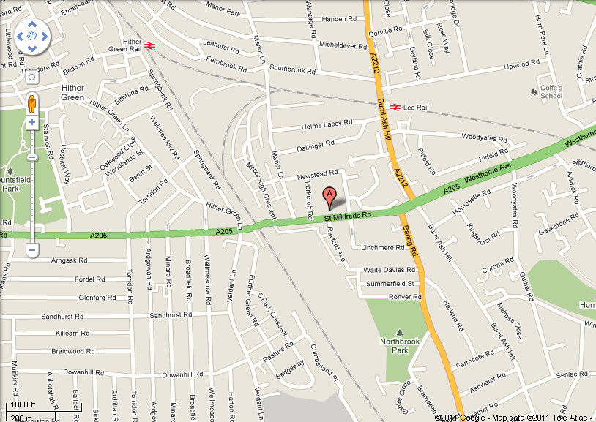

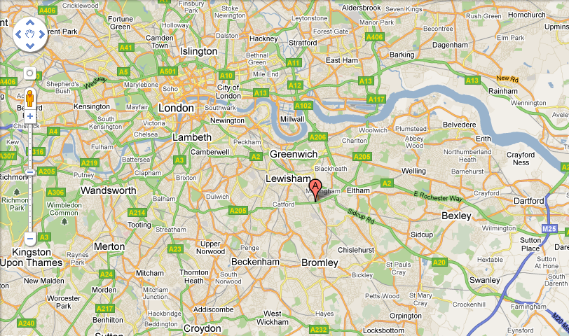
Interior – 1bed

Entrance Hall
Reception 12'6" x 8'4" (3.8m x 2.54m)
Kitchen 9'3" x 7'4" (2.82m x 2.24m)
Bedroom 10' x 10' (3.05m x 3.05m)
Bathroom 4'5" x 9' (1.35m x 2.74m)

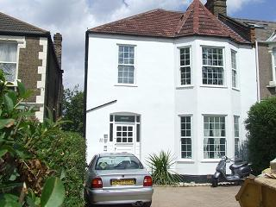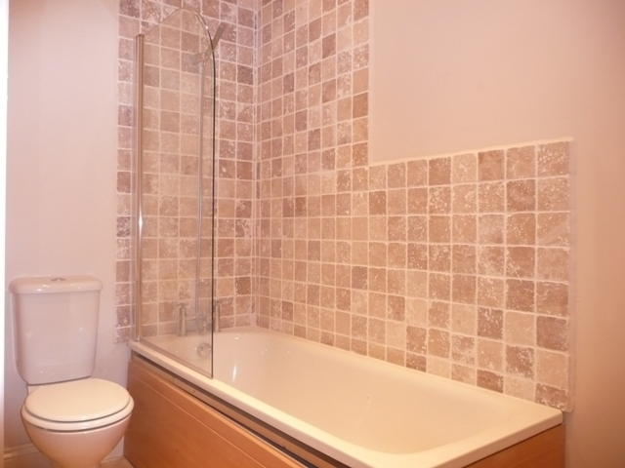

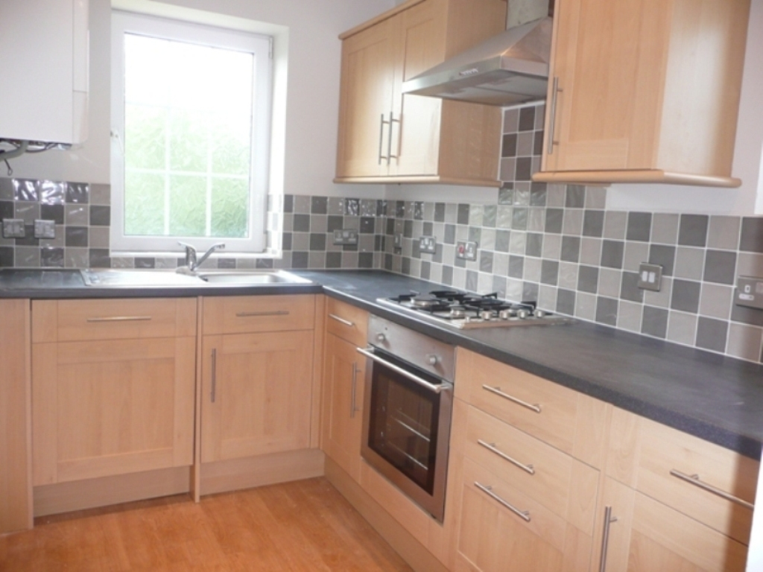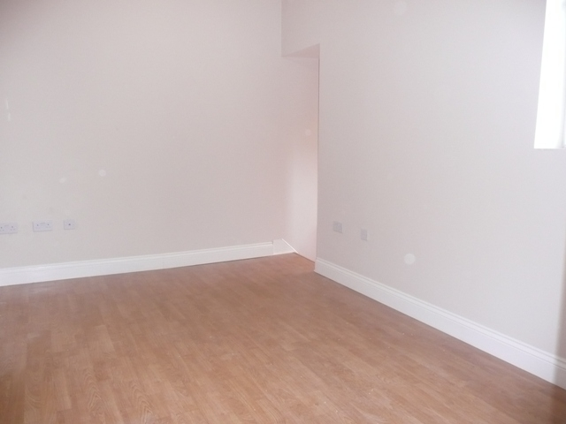

Interior – 2 bed duplex apartment

Communal Entrance Via hardwood & glass front door, carpeted stairs to first floor
Entrance Hall Hardwood front door, carpeted stairs to bedrooms and bathroom
Reception 14'3" x 10'9" (4.34m x 3.28m) Double glazed bay window to front, fitted carpet, radiator, coving, panel door
Kitchen 6'2" x 8'7" (1.88m x 2.62m) Double glazed window to front, wood fitted wall & base units with stainless steel furniture and roll edge worktops, built in oven hob & extractor hood, plumbed for washing machine, part tiled walls
Landing Velux windows to side & front, fitted carpet, coving.
Bedroom 1 10'6" x 10'4" (3.2m x 3.15m) Double glazed window to rear, panel door, coving, fitted carpet.
Bedroom 2 9'11" x 10'7" (3.02m x 3.23m) Double glazed Velux window to rear, coving, fitted carpet, panel door
Bathroom 10'5" x 12'8" (3.18m x 3.86m) Double glazed window to front, free standing claw foot bath, low level WC, pedestal wash hand basin, eaves storage, radiator, part tiled walls.

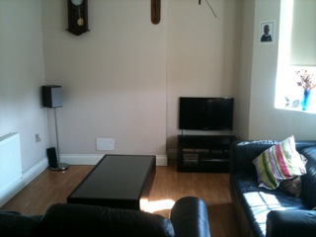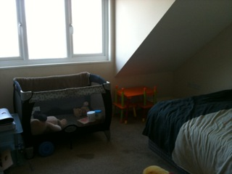

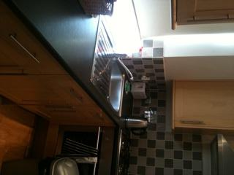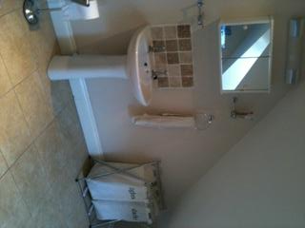

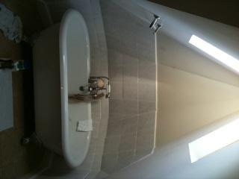

1 bedroom: Sales Comparables

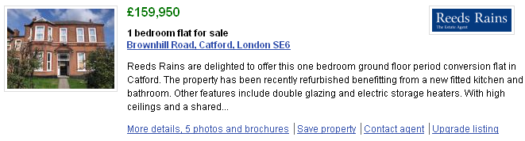

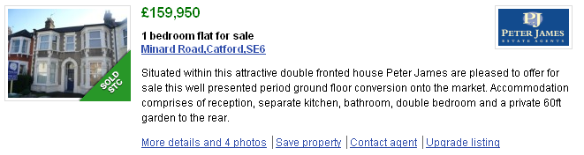
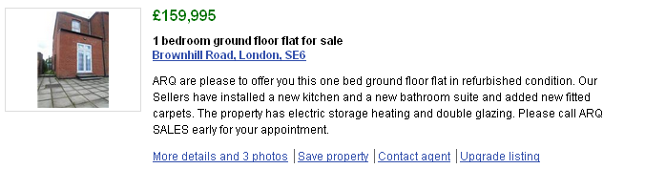

2 bedroom: Sales comparables

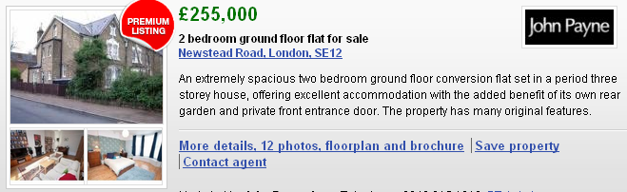

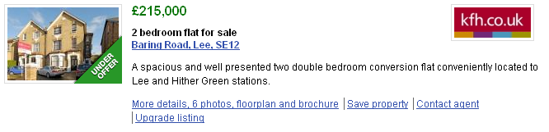
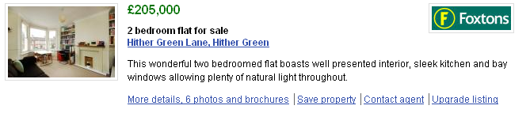

Local Estate agent comments

John Payne Estate Agents – Mr Chris Wadeson

1bed - £160, £165k.

2bed - £185k

Recently sold a 1bed purpose built flat in Staplehurst Road on 11/1/11 for £173k

KFH Estate Agents - Mrs Patricia Irwin-Brown (she has seen the properties)
1bed - £155k

2bed - £185k

Recently sold a 1bed for £158k.

Sold the following 2bed - Bearing Road – 6/12/10, £205k

Mann Countrywide – Sarah Morris

1bed - £155k

2bed - £185k

Lease length – 99 years on both
Service charge & Ground Rent combined - £250 per annum
1 bedroom: Lettings comparables

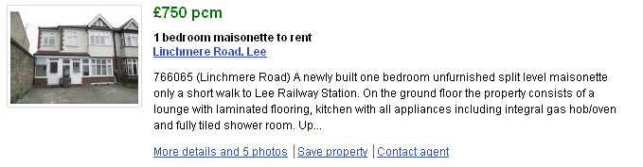

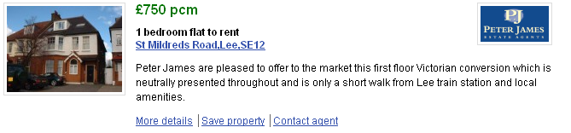

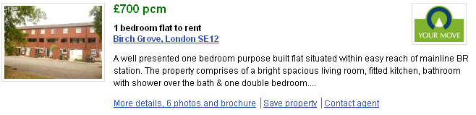

1 bedroom Tenancy:
Currently tenanted at £650pcm
Rent day 12th of every month
2 months notice required to move tenants out

2 bedroom: Lettings comparables



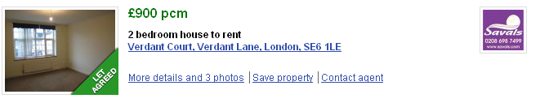

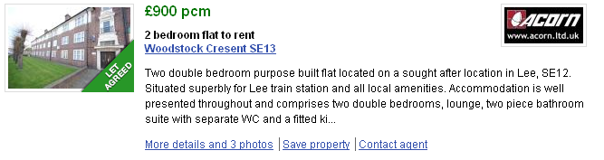

2 bedroom Tenancy:
Currently tenanted at £850pcm
Rent day 26th of every month
2 months notice required to move tenants out

